January 20th, 2006

Today’s Lecture was a continuation of Discontinuous Gel Electrophoresis. Professor Silvius reviewed the essential conditions for creating a stable, moving boundary and then described how proteins separate as a result of this boundary.

The first case that was discussed used the simple model where the cation (C+) is common and the anions (A⁻ and B⁻) are different. Consider the cartoon of a gel below where A⁻ is the trailing anion, B⁻ is the leading anion, and the dashed line represents the boundary between Zone 1, where A is, and Zone 2, where B is. The minus end is the cathode and the plus end is the anode.

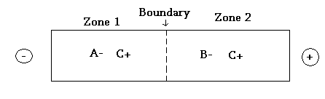

To obtain a sharp, stable, moving boundary a minimum condition must be met, whereby the absolute effective mobility (m_{eff}) of A⁻ in zone 1 must be less than the absolute m_{eff} of B in Zone 2:

Equation 1: |m_{eff} (A in zone1)| < |m_{eff} (B in zone2)|

Additionally, if a boundary is to be perfect and stable while moving, then it must be true that the velocity of the trailing anion (A⁻) in zone 1 equals the velocity of the boundary between zone 1 and 2 which equals the velocity of the leading anion (B⁻) in zone 2. Or

Equation 2: V_{A}⁻_{Zone1}= V_{boundary}= V_{B}⁻_{Zone 2}

We do not want either ion A or B to move ahead or behind its boundary because this will create a gap where the electric field will build up and suck unwanted ions into the gap, so for the steady state to be true, the above must occur.

Recall that the velocity in a given zone is the product of the m_{eff} multiplied by the local voltage gradient (dV/dx). Therefore, the m_{eff} can be related to the velocity of the zone by the equation below:

Equation 3 : m_{eff}(A)_{zone1} x (dV/dx)_{zone1}=m_{eff}(B)_{zone2} x (dV/dx)_{zone2}

But since |m_{eff} (A in zone1)| < |m_{eff} (B in zone2)| when the boundary is moving, (dV/dx)_{zone1} must be greater than (dV/dx)_{zone2} for the equality in equation 3 to be valid. This too is a minimum, essential condition to potentially obtain a sharp, stable, moving boundary.
Knowing that (dV/dx)= (i/λ) where i is the net current per unit cross-sectional area and λ is the conductivity, the complete condition to get a stable, moving boundary is:

Equation 4: (λ_{zone1})/ (λ_{zone2}) = m_{eff}(A)/m_{eff}(B)

Equation 4 can be worked out to give yet another condition to set up a moving boundary (Note: this was not derived in class):

Equation 5: [A]_{Total} = m(A⁻)* [m(B⁻) – m(C⁺)]
[B]_{Total} m(B⁻)* [m(A⁻) – m(C⁺)]

Where m is the true mobility’s for the ionic forms of A⁻ and B⁻ and not the effective mobility’s for A and B. The species A and B are present only in the forms with a charge of 0 or -1 and the cation only takes the form of a single positive charge (he didn’t say this in class, but it’s written in the handout).

Equation 5 gives a recipe for how you should make up the solutions in the two compartments of your electrophoresis system to get the perfect, stable boundary. There is a modified form of this equation that is useful to determine how much protein is present in the tiny bands that form when we do discontinuous gel electrophoresis. Silvius mentioned there is a question in the handout about it, so we should understand why proteins make such thin disks in gel electrophoresis. This is pre-emptive though, as we will discuss proteins further down. Note that we are not responsible for memorizing Equation 5.

To be more specific we will now have the A⁻ species as glycine and the B⁻ species as Chlorine. (C+ is usually Tris).
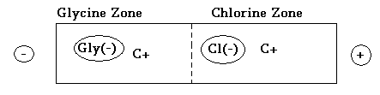

As in Equation 2: V(Glycine)_{Glyzone}=V_{boundary}=V(Cl)_{Clzone.}

So why does the boundary remain/become infinitely sharp? The thermodynamic reason is that when you constantly put energy into a system, as opposed to when a system is at equilibrium, you can make the system ‘play by new rules.’ If the boundary were to broaden out, the Cl ions would slip back and the Gly ions would slip forward. But what happens if…….

Only glycine slips ahead of the boundary? Depicted below is a glycine ion ahead of the boundary in the chlorine zone.
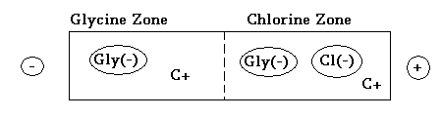

Remember that (dV/dx)_{zone1} must be greater than (dV/dx)_{zone2.} Here the voltage gradient in the Chlorine zone is less than the voltage gradient in the Glycine zone,
(dV/dx)_{Clzone} < (dV/dx)_{Glyzone}, so if glycine slips ahead of the boundary it will slow down and the velocity of the others will increase to satisfy the equation V(Glycine)_{Glyzone}=V_{boundary}=V(Cl)_{Clzone.} So the increase in the velocity of the boundary causes it to rapidly overtake the Glycine ion and bring it into its own zone. This is a self-focusing property of the boundary.

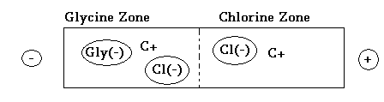
What happens if a Cl ion slips back into the Glycine zone?

The voltage gradient is higher in the Glycine zone so the Chlorine ion experiences a higher voltage gradient than if it was in the Chlorine zone. So the velocity of the Cl ion increases higher than the V_{boundary,} it moves ahead of the boundary, thus reestablishing itself in the Chlorine zone.

As long as the energy is continuously applied to the system (gel), the sharpening of the boundary will persist as ions continuously reposition themselves in their respective zones.

With our knowledge of how ions work in discontinuous gel electrophoresis, we can now discuss how proteins will behave in the same system. First, we have to examine the different components used to run a discontinuous gel, which is shown below. On the left is the compartment and on the right is the important components of that compartment:

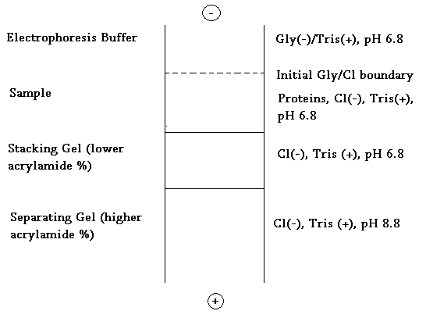

At pH 6.8: 1) Glycine is above its pI, therefore it is net anionic
2) |m_{eff} (Gly)| < |m_{eff} (Cl)|
3) We assume that all proteins in the sample are in a net anionic form when they are loaded onto the gel as free proteins or as protein SDS page complexes etc. What if proteins are not all net anionic? They would travel up toward the cathode and electrode buffer in the upper compartment. This especially occurs in native gel electrophoresis where SDS is not used.
4) For all proteins to be separated it must be true that:
Equation 6: |m_{eff} (Gly)| < |m_{eff} (All Proteins)| < |m_{eff} (Cl)|
in the stacking gel and the sample gel, but not in the separating gel, otherwise the proteins of interest will not be sharp enough. Equation 6 is a key parameter for protein separation.

In general, proteins are a minor species, so they must follow the more abundant species like Glycine and Chlorine. At the start of the run, the Chlorine zone is at the sample buffer and the Glycine zone is at the electrophoresis buffer (see the Gly/Cl boundary in the above figure). The boundary eventually moves into the stacking gel, then finally the separating gel.

The protein starts off in Chlorine zone then moves slower then Chlorine ions because it has a lower m_{eff} and similarly, it moves slower then the boundary. So the boundary will gradually overtake all the protein molecules in the sample and the protein falls behind.

What happens if the protein falls behind the Gly/Cl boundary?
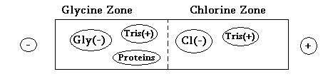

The protein’s velocity is greater than Glycine in the Glycine zone because
|m_{eff} (Gly)| < |m_{eff} (All Proteins)| from equation 6. The protein will therefore accelerate toward the boundary. So if the protein speeds up in the Glycine zone and slows down in Chlorine zone, the proteins accumulate at the Gly/Cl boundary. The microstructure of the protein stacking is illustrated below where the arrows represent the velocities of the proteins:
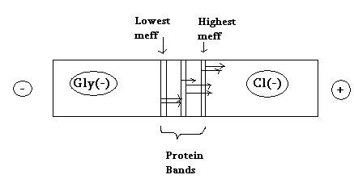

The proteins sort out into ultra thin (µm) zones in altering of their m_{eff} value.
All the protein bands lie between the Glycine and Chlorine boundary. This is the purpose of the discontinuous gel: to concentrate the protein at a certain point.

Once stacking is complete the ‘stacked’ proteins now enter the separating gel. In the separating gel the following occurs:
- The acrylamide percentage increases, which decreases the absolute value of m_{eff} for proteins, but this has little effect on glycine mobility. There is a considerable increase in frictional resistance felt by the proteins.
- The pH increases from 6.8 to 8.8, which leads to a large increase in the absolute m_{eff} of glycine because a lot more glycine is in the anionic form.

As a result of the above points, the following is true in the separating gel:

Equation 7: |m_{eff} (all proteins)| < |m_{eff} (glycine)| < |m_{eff} (Cl⁻)|

So proteins are no longer forced to stack at the Glycine/Chlorine boundary and the boundary overtakes the proteins and passes them as depicted below:

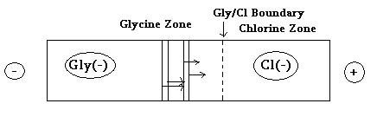

The velocities of the proteins are now different (as depicted by different arrow lengths) and so are their effective mobility’s and therefore the proteins are separated based on macroscopic properties just after the separating gel is entered.

And that is how proteins separate on a gel.

